url: [https://www.interstellar-nft.com](https://www.freelancer.com/users/l.php?url=https:%2F%2Fwww.interstellar-nft.com&sig=6092e0f7b48fb56e8e30af5a48abad3587222882ffbbd30bec0654017350ed5c)

Blockchain-Dapp-Game-Development-Stellar

25USD/hour

[Krzysztof M.](https://www.freelancer.com/u/InterstellarKris?from=messaging&ref_project_id=33151689)

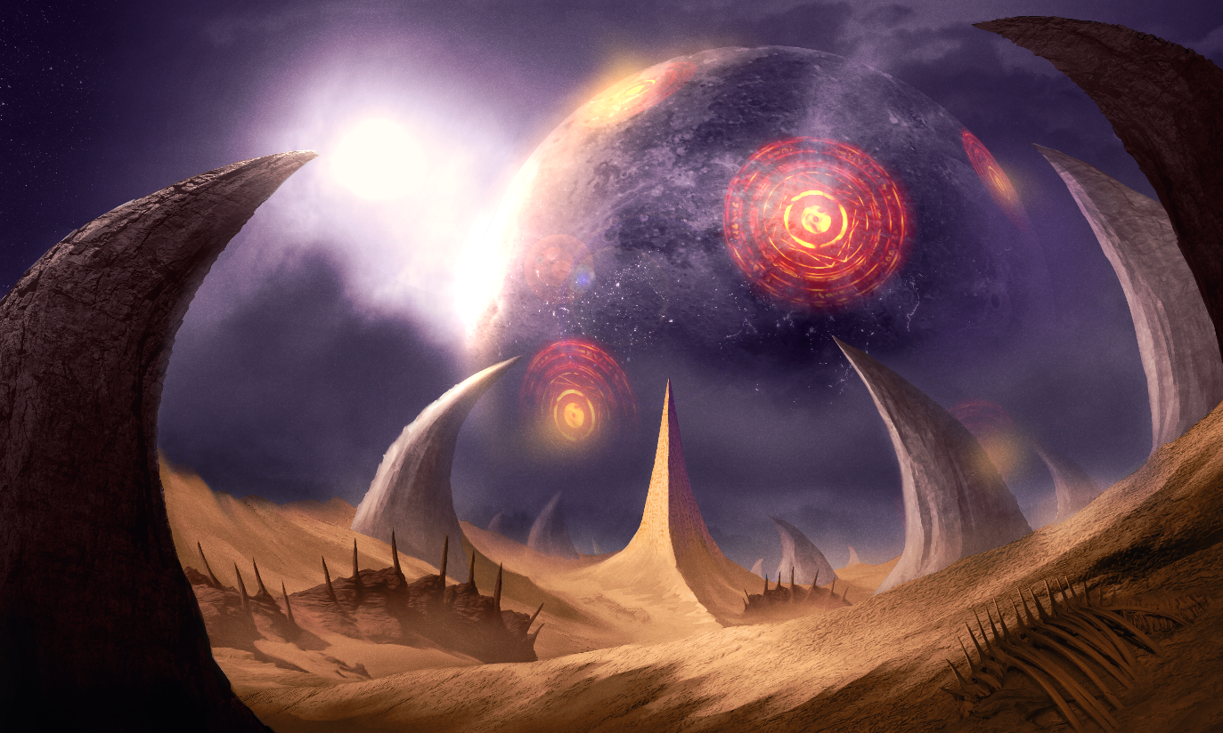

Game Detail Information:

**Title : InterStellar** (Your team can set name of this crypto game. This is only example)

Your team can set this title. Good for you?

Game Engine: Unity or React (We can discuss about it again.)

I am going to use unity. Good for you? You can write here. Unity works yeah as we’ve started buying graphic assets for it.

Good

Game Server: Node.js.

And then we will use node as game server. How about you? I’ll have set this up from my side right?

Sure. When do you want this done by? In next two weeks. First, I am going to run this game in my pc. Okay no problem

Database: MongoDB.

And then how about you? MongoDB? Yes that’s fine

Platform: Web browser, Android.

This game will be played on web browser and android. What about IOS?

Let me think about this.

Because my computer is not apple. So I cannot install mac os in my PC. Right okay don’t worry about it now. Good crypto game is mostly played on web browser and android. If this is possible, I will update this game on IOS. That’s okay let’s stick with PC and android for now. Good thanks for your understanding.

Game Control:

W key : Up

S key : Back

A key : Left

D key: Right

Q key: Change Weapon

Click Left Button of Mouse : shoot

Click Right Button of Mouse: Charge Force.

This is game control. Do you understand? Yes that’s great, I like the change weapon feature. Lol thanks. Do you understand about charge force? So like to charge the wepon before it shoots and does more damage? This is for specific shoot that is very strong. Yeah great idea! Okay good.

Game Mode: **Single Mode.** (one player) in this mode, one player can play with different levels.

**Match Mode.** (two player) in this mode, competition between two different users can play.

**Multi Mode.** (six player) In this game, six users in max can play.

**Team Mode**. (Between teams with the same numbers of users can play.)

We will discuss about mode methods in the end of this doc.

This is game mode. We will discuss about these end of this doc. Let’s skip this. Okay

weapon equipment: Hydra Blaster, Centaurus Blaster, Andromeda Cannon, Dorado Scyth.

We can add more items later.

I think we should set 2-3 items in every spaceship. So number of items can be 12.

Are you agree? Because if we have many items, we will sell lots of items in our marketplace. Yes I agree, I’m going to look for some more weapons too. In that time, your team should prepare 3D or 2D model for this item. Right? Yes that’s what we’re going to do. Good.

Spaceship Equipment: Hydra Speeder, Centaurus Speeder, Andromeda Battlecruiser, Dorado Destroyer.

We can also add more spaceship equipment later.

Also. I think you will agree. Like this weapon. Yeah that’s fine

Landscape: Hydra, Centaurus, Andromeda, Dorado.

We can design like images that you have sent me.

This is also. We can add more landscape.

I have two game play methods.

~~First, all methods use the same game environment.~~

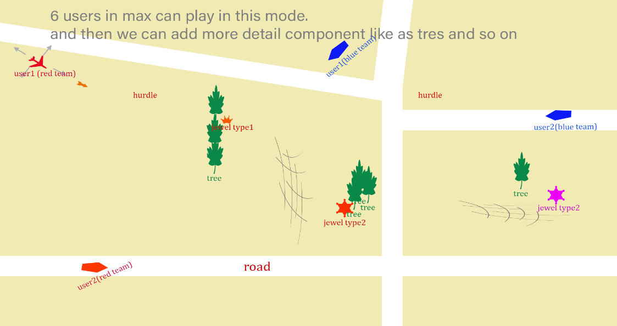

~~Single and multi mode are using both this methods now.~~

Second, Single mode is different from Multi mode.

Single Mode:

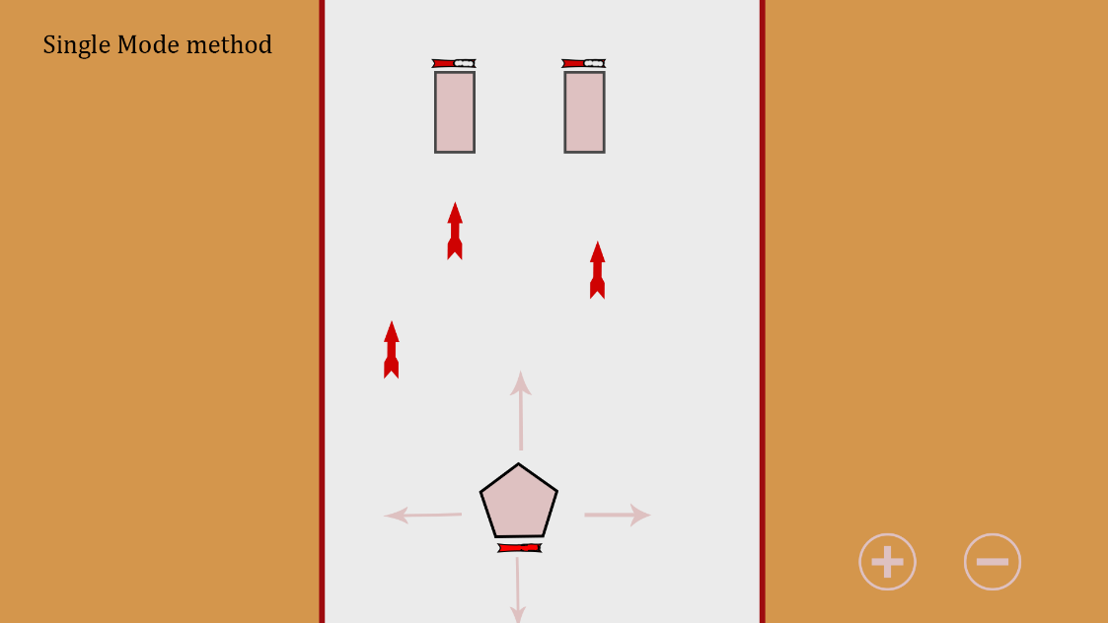

Here, user plays this mode with several levels.

When User win through each level, difficulty is more increasing now. In that time, user can get more tokens in next levels. User can only win through with better Weapons Item. User can buy this weapon item in our NFT Marketplace. I think we should set several levels in each landscape.

Yes exactly!! That was my basic idea too, I will send you the game designs I’ve done but the single mode is very similar to yours so I’m glad we’re on the same page. Lol 😊 :D So do you agree that single mode is different from multi mode? Yeah So you agree two methods. Right? I think two methods will give more game utility so I agree with you. Cool. 😊

Multi Mode:

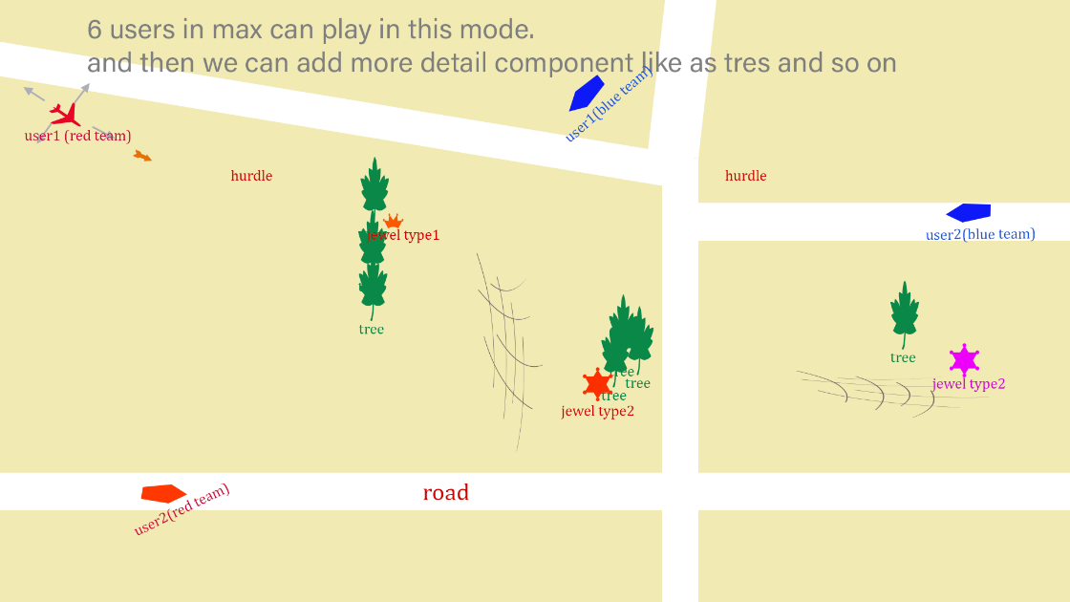

**This multi mode method will be an advantage we have.**

In multi mode method there are some modes.

You can read these modes and then write down about your opinion.

1. Match Mode (Two players can play this mode). In this mode, two players can play this game against each other. Before they play war in this mode, they can get items that they want in our market place. And they can make contracts before game. The concept of the contract is that users can gamble with tokens. Before game, two users can set amount of tokens using in gambling. And then users send amounts of token that they have set before game, to admin wallet. And then users play this game each other. After Game, Winner can get all tokens that they sent to admin wallet. So the winner will receive double the amount of tokens sent to the admin wallet. In that time, admin wallet can get some amount tokens from two users(example 5% of all amount tokens because transaction and gas fee or profit of game site manager. We can discuss about the percentage of this amount). How do you think about it? Are you interested in this idea? I like this idea definitely, the game mode can then be a battle between the two players which is cool, I’ll talk about this with the team but I’m sure they will like it 😊

Here main profit this is. That’s smart I love it haha. You can read other mode.

1. Team Mode (Six Users in Maximum). This mode is very similar to match mode. The difference between these modes is that users have different numbers of members. You can split 4 or 6 users into two teams. And then in each team, each user can get items and so on(we can add more options) and then make contract like match mode and then send tokens to admin wallet before game. Start the game! Two team can play with team members. In each team, each user play game by using his specialty to win own team in this mode. Game end and then winner get 2X tokens from admin wallet. (in this mode we can set profit of our development team). This is good for us and everyone. I think this mode will be mostly used than Match mode.

This is also a good idea I think, I’m not sure we’d need both team mode and multi mode as of yet. In Multi Mode users can play invidually and then in team mode users can play with own team. In that time. In Multi mode game server give token by using ranks of own himself. And then in team mode users can get same amount of tokens with other user in his team. Understand? Right okay that makes more sense, I’ll run it by the team but I see where you’re coming from as it gives the user incentives to play .

I don’t understand well. Can you explain about it again? I understand your point about the team mode and the multi mode I think it’s a good way for the player to carry on coming back and playing the game, I’ll just have to confirm with the team if they would like both team mode and multi mode. Does that make more sense? Yes. I think these modes are very important. And then they have own advantage in each mode. Team mode players can grow team sprit and then in multi mode players will try to be winner in game mode. So they can get more tokens when player get high ranking of this game

. so I think these two modes are very important for us and players in crypto game. 😊 that’s good I agree

1. Multi Mode (Six users in maximum). I also attach great importance to this mode. This mode is a combination of match mode and team mode. In this mode, users can play against each other. Users can set amount of token to use in this mode. And then all users send token to admin wallet. Start the game and users can play against each other. End the games. Rankings of users will be determined. User can get token by their ranking(in this mode we can set profit of our development team). I think this mode will be also mostly used like Team mode. Are you interested in these all modes?

This is good and important.

**In these modes we should set users that buy more and more items in our marketplace to be winner in our crypto game. They can earn more than tokens used to purchase items in this crypto game. Here, loser will get more items in our marketplace to be winner. And then let’s see about items in our marketplace. Items can be weapon item (for fire power) and bulletproof item (for blood) propeller item (for speed) and so on. We can add items for more idea. So our items in our marketplace can be sold well and then we can get more profit from our crypto game. And then we can add variety option of game. How about you? I think my idea will be good for us. I am sure. If my idea is completed, we can get great success in this crypto game.**

**Yeah that’s good, my thinking was, that we’ll have a marketplace for the weapons as you described then user can purchase different items to increase the level of his spaceship, so it can shoot better rockets or is faster when he buys the propeller etc etc**

**Yes we can set more times not only weapons but also bulletproof and propeller items and so on. This is good for us. ! 😊 great yeah I’ll have a look a different designs for these 😊 and then these items can be used player or team to be winner in multi mode and team mode. :D**

**This is generally game flow that I have thought. Of course we should add more idea into this. Look at this.**

Game flow method:

First page:

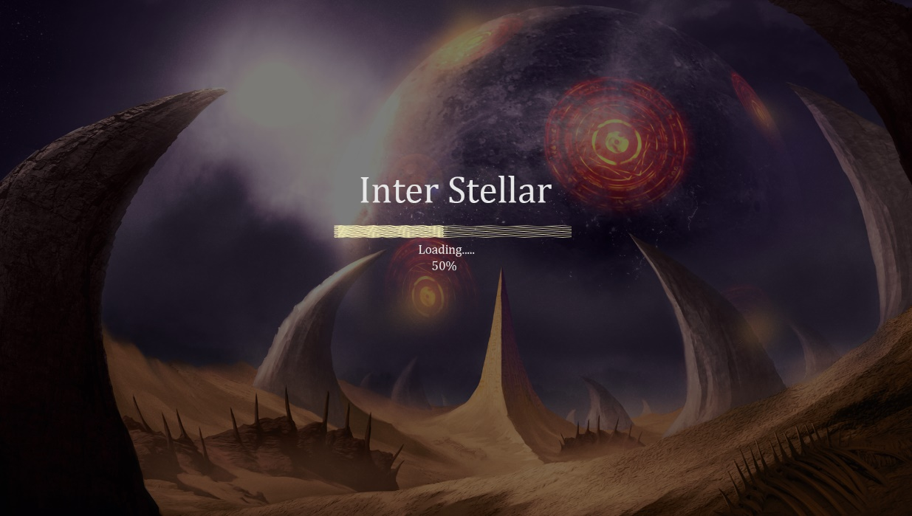

This is loading page. Of course design will be different from this. I understand, good idea though

Login Page:

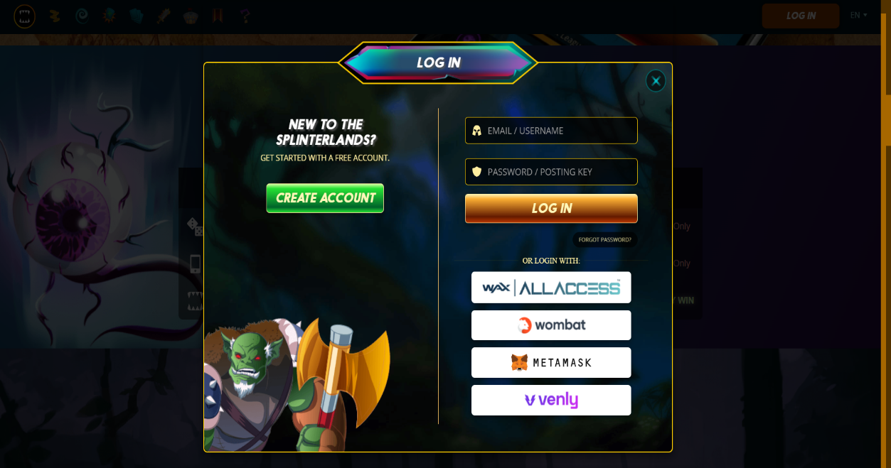

This is login page. As I have mentioned in the past, player before game, should input email or his own name and password or mnemonic pharse. I agree

And then this page is select mode page. Of course these pages will be different from these images. These images is that I have created for this discussion.

Second Page:

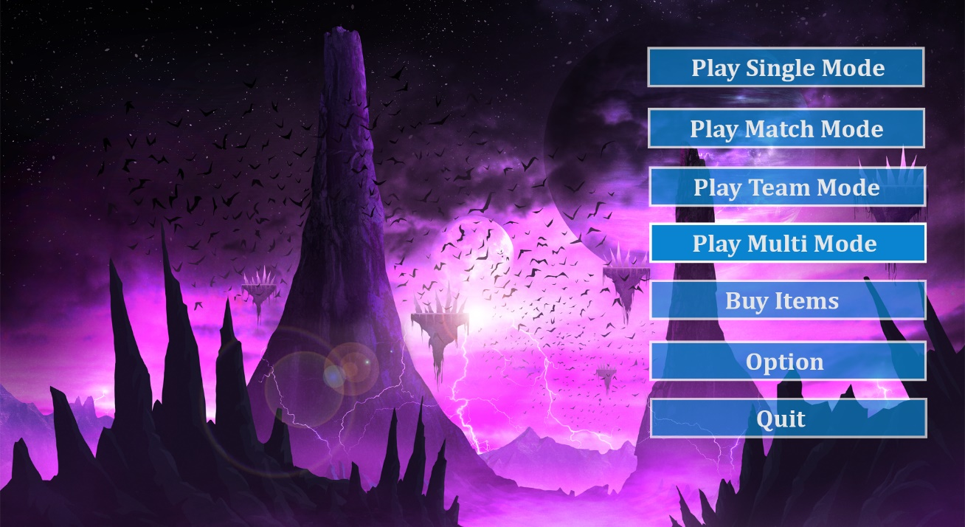

Third Page (single Mode):

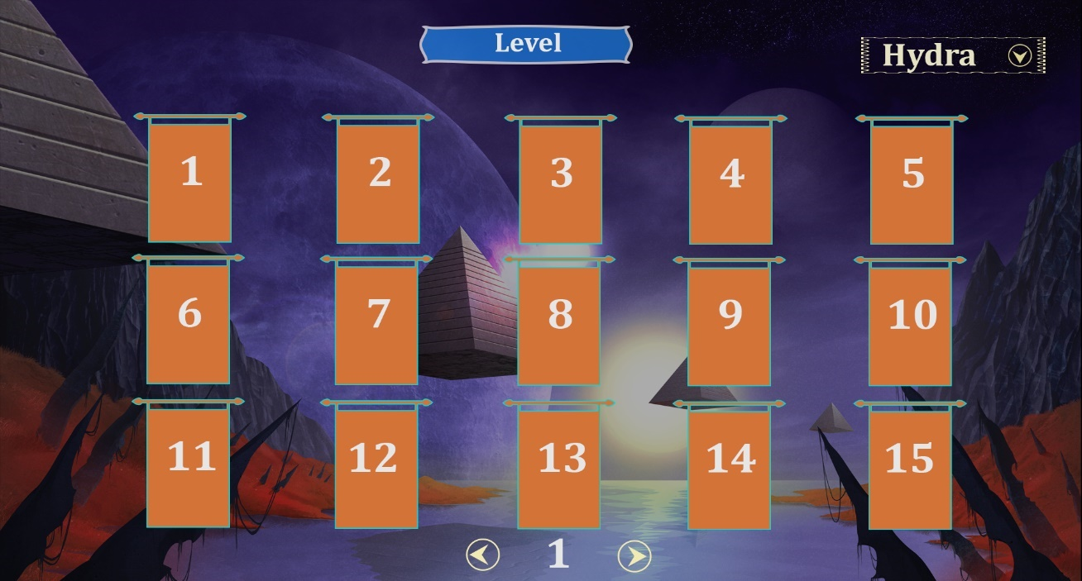

In single mode this is select level page. Right top. Landscape select. This is good, what I was thinking too, quick question. Could we have these pages in 3D as the game is 2d? So we can set 3D pages, this is possible. But we can meet some risks. But I will complete this task perfectly. 😊 Love to hear it!!

This is user select pages of multi mode

That’s very good I like the design behind it

Third Page(Multi Mode):

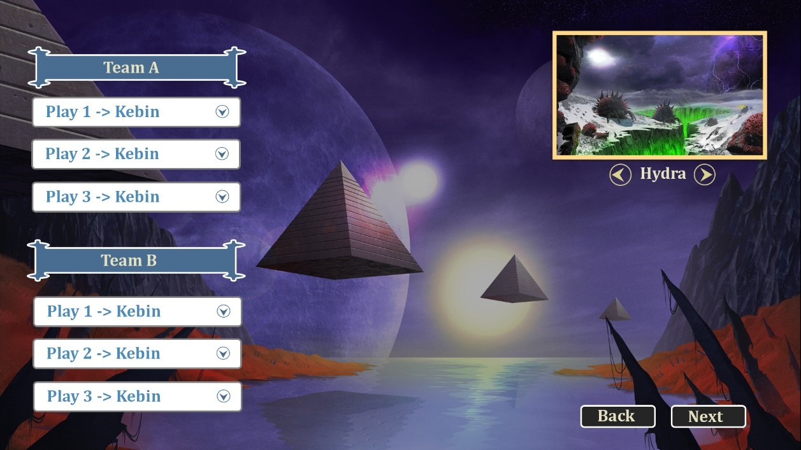

Last Page (Single+Multi Mode):

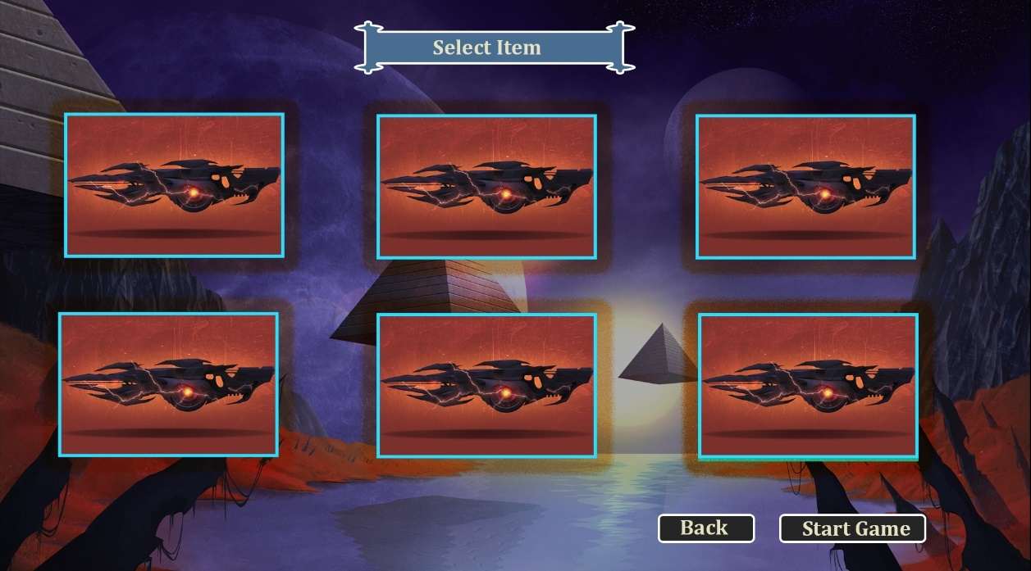

In this page user can buy item in our NFT marketplace. Of course we can add more option and more items like prophella and so on. Yeah exactly that’s good

And then users will play this crypto game.

Very interesting game will be performing in that time. Finally, game end. And then this app go to end page.

Reward Page.

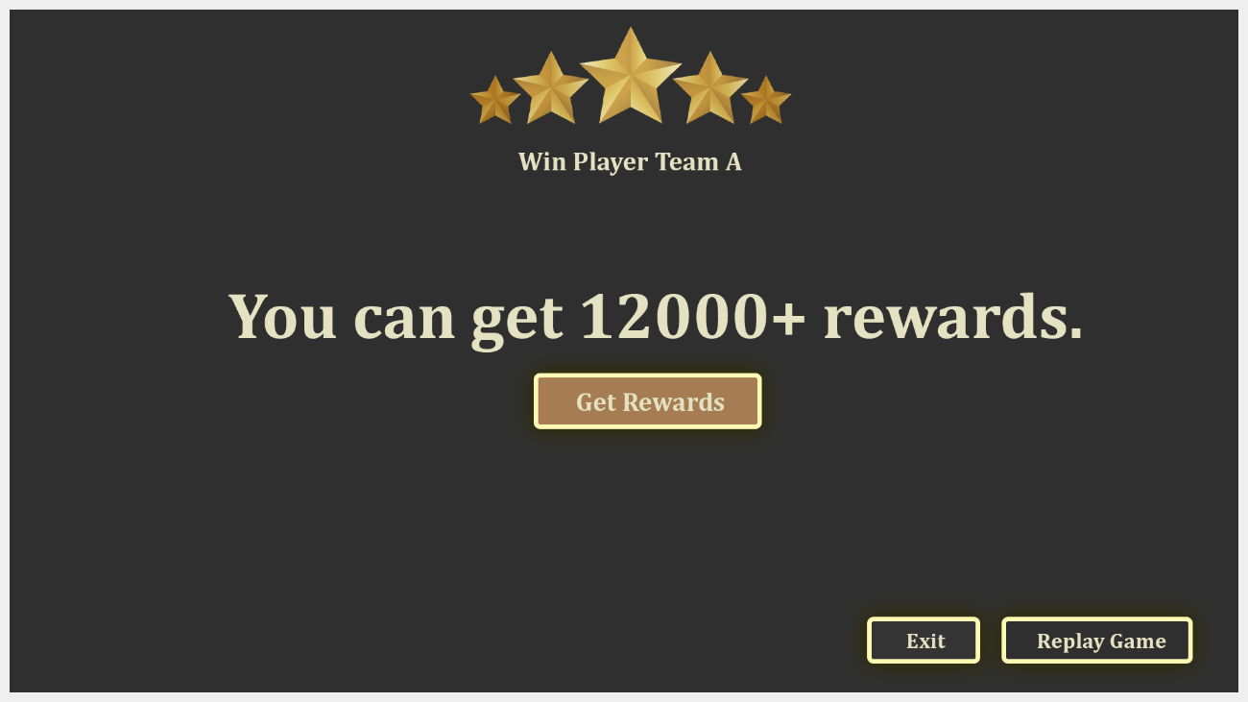

In this pages, winner will get 2X tokens them to send to admin wallet. Great yeah similar to what I was thinking too

That’s all.

And then I should explain about other one.

We should add another one page. Select game room in multi mode.

I think you don’t understand well. For example.

Sorry I think it takes more time.

For example create game room in multi mode. And then other user get into this room that old user have already created.

This room will has some levels.

When user gamble, we should set tokens to use in gambling.

For example Level1: we can set 100-500 eth.

Level2: we can set500-100 eth…….

So if another user don’t have lots of token, he will select level 1.

If another user have lots of tokens, he will select high level.

If he select high level, if he is winner, he will get more tokens. This is gamble logic.

How about you?

I like the idea definitely, I’m guessing we would need a minimum amount of users for this? I think 6 players is good for us. In maximum.

Minimums method is same match mode. Two players. Yea that’s good if you prepare expert game server, we can increase amount of players. That’s okay for now, I’m not worried about lots of players at the moment good. That’s all.

Great! I really liked what you’ve done so far 😊 😊 :thumbsup: